How to set subsurface scattering in Daz3d

# Introduction

Setting the proper subsurface scattering values in Daz3d will allow for more natural looking skin textures in your renders. This guide will walk you through changing the following settings:

* Base color
* Base color effect
* Translucency color
* Translucency weight
* SSS reflectance tint
* SSS mode
* Transmitted measurement distance
* Scattering measurement distance
* SSS color
* SSS direction

The following example images were taken using the following free HDRI map: <https://hdrihaven.com/hdri/?h=flower_road>. This map has a strong and bright sun, which allows the subsurface scattering effects to be seen more clearly while setting them up.

Before beginning, load the flower road HDRI map in your environment settings. Next, enable **spectral rendering** in the render settings. Set the **spectral conversion intent** to natural, and the **spectral observer** to cie1964. This will render colors more natural and realistic.

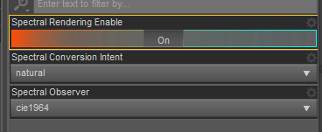

# Base Color Settings

Set **base color** and **translucency color** to white (1.0, 1.0, 1.0) and use the diffuse texture map for both. Some characters use a different map for translucency color. If yours does, change it to the diffuse map.

The **translucency weight** determines the fleshiness of the skin and should be a value between .85 and .95. There is no need for a texture map here.

If the skin looks too dark, there are two ways to adjust it. First, you can increase the gamma or brighten the texture in your photo editing software of choice. Second, you can go to the parameter settings for translucency color and turn off limits, which will allow you to set the translucency color values to a number higher than 1. The first option generally gives better results.

Set the **base color effect** to scatter & transmit or scatter & transmit intensity. This allows for more control of the SSS settings.

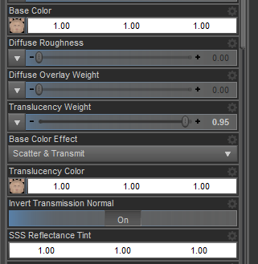

# SSS Settings

First, set the **SSS mode** to chromatic. This will enable the option to change SSS color.

**Transmitted color** should always be set to (0.99, 0.99, 0.99). If it is set to full white, you’ll get a lot of glowing on the skin.

Set the **SSS color** to (0.99, 0.84, 0.35).

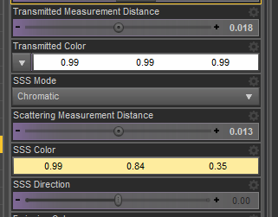

See below for the RGB values of transmitted color and SSS color.

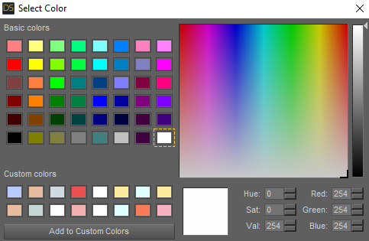

Transmitted color

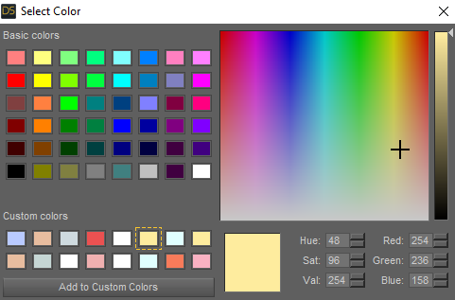

SSS color

The SSS hue color can be changed to affect the skin tone. If the skin is too yellow, change the hue to 30. If it’s too pink, change it to 338. You can experiment with these numbers to see what works best for your character, but those two are good starting points.

The **transmitted measurement distance** and **scattering measurement distance** are based on the height of the character in centimeters. For a character that is 180cm, the **transmitted measurement distance** will be 0.018 and the **scattering measurement distance** is 0.013. The average Genesis figure is about 180cm, so these values should be fine for most figures. If you know the specific height of your figure, use that value for the transmitted measurement distance and subtract 5 for the scattering measurement distance.

**SSS direction** should be set to 0 by default. If it has been changed on your specific character, reset it to 0. Having a value other than zero can cause fireflies in some cases.

After changing the above settings, your character should now have a much more natural looking skin tone. See below for a before/after comparison.

